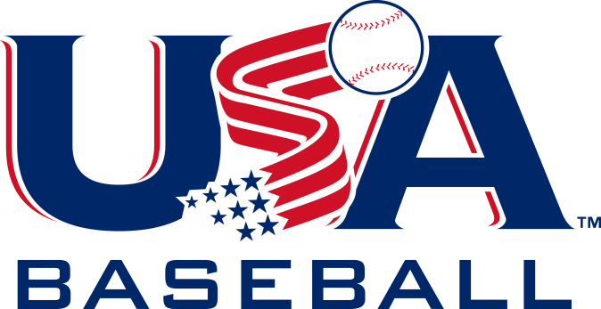

FOR IMMEDIATE RELEASE: August 7, 2015
Contact: USA Baseball Communications -- mediarelations@usabaseball.com, (919) 474-8721 x225

USA BASEBALL, MEMBER ORGANIZATIONS ANNOUNCE NEW YOUTH BAT PERFORMANCE TESTING PROGRAM
Implementation of USABat standard begins on January 1, 2018

DURHAM, N.C. -- USA Baseball, the national governing body for the sport of baseball in the U.S., in conjunction with participating national member organizations announced today the decision to adopt a new method for measuring bat performance in the testing of youth bats. Informed by the research of leading scientists on the USA Baseball Bat Study Committee, and supported by its NMOs, -- including the American Amateur Baseball Congress (AABC), Amateur Athletic Union (AAU), Babe Ruth Baseball/Cal Ripken Baseball, Dixie Youth Baseball, Little League Baseball and PONY Baseball -- USA Baseball has concluded that recent advancements in science, engineering, technology, and the materials available to fabricate non-wood bats, now allow the manufacturers to construct youth bats that can perform at a wood-like level through the entire range of lengths and weights of youth bats.

The new USA Baseball bat standard (USABat), which will apply to bats that are classified below the NCAA and NFHS level of play, will be implemented on January 1, 2018, allowing the bat manufacturers sufficient time to bring these bats to the marketplace.

“USA Baseball is pleased, with the support of our participating national member organizations, to announce the USABat standard,” said USA Baseball’s executive director/CEO, Paul Seiler. “Beginning with the launch in 2018, we will take another step forward in making our game more uniform at the youth level and ensuring the long-term integrity of the game.”

Similar to the NCAA and NFHS BBCOR standard, which helped to eliminate discrepancies with different length bats and thus provide a more direct measure of bat performance, the new USA Baseball bat standard will allow youth baseball organizations in the United States to reach their goal of establishing a wood-like standard, a standard that will provide for the long-term integrity of the game.

There will be no immediate change to youth baseball organizations’ bat rules. All bats, currently accepted for the respective leagues, remain permissible through December 31, 2017. Each participating national member organization will incorporate the new standard into their rules for the 2018 season and will begin, with this announcement, to inform their membership of the USABat standard.

Frequently Asked Questions about the USABat standard:

Which national member organizations are implementing this new standard?
To date, the following organizations are participating (in alphabetical order): American Amateur Baseball Congress (AABC), Amateur Athletic Union (AAU), Babe Ruth Baseball/Cal Ripken Baseball, Dixie Youth Baseball, Little League Baseball and PONY Baseball.

Why the change to a wood-like standard?
USA Baseball’s national member organizations believe that a wood-like performance standard will best provide for the long-term integrity of the game. The new standard will not have a drop-weight limit, so young players can use bats made with light-weight materials.

Why not just use wood bats?
Wood is a scarce resource. The new bats will be designed to perform much like wood, where its performance will be limited to the highest performing wood.

How is the USABat standard different from the BBCOR standard used by the NCAA and NFHS?
Both the USA Baseball and NCAA bat performance tests are based on the coefficient of restitution from a bat-ball impact. The scale of results is different, however, since they use different test balls and test speeds. The testing difference is necessary to address the various levels of play in the respective age groups.

Why is USA Baseball involved?
The national member organizations asked USA Baseball as the national governing body to take the lead in this process to establish a new standard. Many other national governing bodies set and enforce standards for the equipment in their respective sports. To that end, USA Baseball established a Bat Study Committee of leading scientists and conducted theoretical modeling, field testing and lab testing. The committee shared its findings with the national member organizations, who then endorsed the new USABat standard.

Who were the scientists on the USA Baseball Bat Study Committee?
Alan Nathan, Ph.D., Professor Emeritus of Physics at the University of Illinois
Dan Russell, Ph.D. Professor of Acoustics at Penn State University
Glenn Fleisig, Ph.D. Research Director of American Sports Medicine Institute

Why wait until 2018?
The implementation date of 2018 will allow bat manufacturers sufficient time to conduct the appropriate research, design, testing, manufacturing and shipping needed to get new bats into retail outlets. This date also allows the participating national member organizations adequate time to educate their memberships of the USABat standard.

Is my current bat good for league play?
Yes. Current league-approved bats can be used through December 31, 2017.

Is safety the reason for the change?
No. Youth baseball continues to be one of the safest of all sports for youth participants.

How will I know which bat to buy?
All new bats that bear the USABat licensing mark will be permissible for play in the leagues and tournaments of the participating youth baseball organizations.

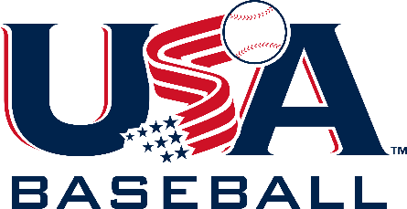

When can I buy the new bat?
It is the intention of the bat manufacturers to make the new bats available in the fall of 2017, in sufficient time for the 2018 season.

About USA Baseball
USA Baseball is the national governing body for the sport of baseball in the United States and is a member of the United States Olympic Committee and the International Baseball Federation. The organization selects and trains the World Baseball Classic, World Cup and Pan Am teams (and all other USA Baseball Professional Teams); the USA Baseball Collegiate National Team; the USA Baseball 18U, 15U and 12U National Teams; and the USA Baseball Women’s National Team, all of which participate in various international competitions each year. USA Baseball also presents the Golden Spikes Award annually to the top amateur baseball player in the country. For more information, please visit USABaseball.com.

###

