2019 Summer League Prep Clinic
Objectives:
- Prepare swimmers of all skill levels for the Summer League season.
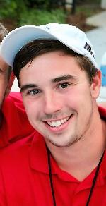
- Focus on proper stroke technique
- Teach common stroke drills
- Practice efficient starts and turns
Coach Pierce Bradshaw:
- Charlotte native
- Swam for Providence High School, West Virginia University, and East Carolina University
- Former head coach for Sardis Swim & Racquet Club
- Current head coach for Covenant Day School, and New South Swimming
Where/When:
- Carrington Swim & Racquet Club (5701 Cary Ridge Dr)
- 6 lane, 25 meter pool
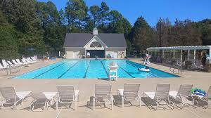
- Heated and covered by a tent
- March 23, April 6, April 13, April 20, May 4
- Ages 7-10: 1:00-1:45 PM
- Ages 11&UP: 2:00-3:00 PM
Cost:
- Ages 7-10: $15 per clinic
- Ages 11&UP: $20 per clinic
- No commitment. Attend as many clinics as you please.
RSVP:
- Email: nsscoachpb@gmail.com
- Cell: 704-241-3546
- Please RSVP 48 before the start of each clinic

