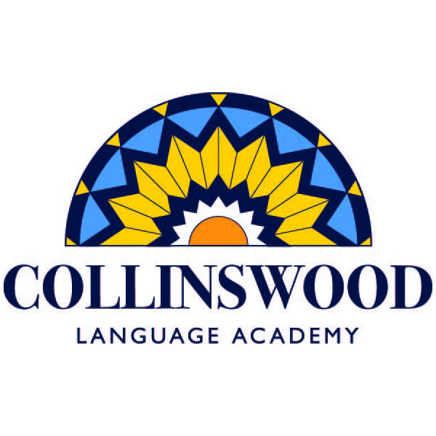

Dear _________________________________,

I am writing to tell you about my school, Collinswood Language Academy. It is a great place to learn and grow!

At Collinswood, we learn for half the day in English and half the day in Spanish. By the time we graduate after eighth grade, we are fluent in two languages! We were the first dual language school in North Carolina and we are a national model of excellence in public education. Last year, we hosted more than 100 visitors from across the country who wanted to learn about our program and our strategies for success.

Over the past several years, we have been recognized as an Honor School of Excellence, Magnet School of Excellence, and an International Spanish Academy School of the Year. In 2014, Magnet Schools of America selected and recognized Collinswood as one of the top five magnet schools in the country!

We are also one of few schools nationwide that has been able to come close to closing the achievement gap among racial and socio-economical groups. Not only are our state test scores much higher than the district and state averages, but we have been successful with challenging our minority, English-as-a-second-language and special-needs populations.

Unfortunately, our school district is unable to provide all of the supplies and resources our teachers need. The PTA funds those resources by raising money each year through our Invest-In-Your-Child campaign. All of the money raised goes directly into our school, covering things such as technology, classroom supplies, teacher training and appreciation, field trips, even printer cartridges and Band-Aids! The best thing about Invest is that 100% of the money raised stays at Collinswood.

Would you consider making a 100% tax-deductible contribution? Every gift, no matter the size, is an important part of our Invest campaign and is greatly appreciated by the students, teachers and staff of Collinswood. To donate, send a check made payable to the Collinswood PTA to the address below. Note Invest-In-Your-Child in the memo.

Collinswood Language Academy PTA
Attention: Invest-In-Your-Child Campaign
4000 Applegate Road
Charlotte, NC 28209

We will mail you a tax receipt once your donation is received. If you have any questions, please contact our Invest-In-Your-Child chair Jenny Robles at jenelle.robles@gmail.com.

Thank you so much for supporting my school and my education!

Love,

