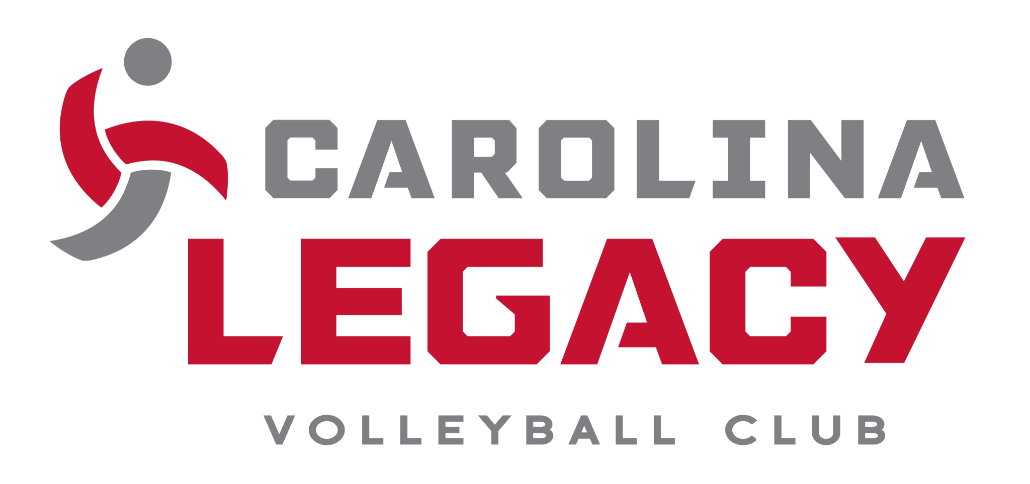

2024 Parent/Guardian Financial Agreement
Semi-National Team

I, ___________________________________ Parent/Guardian of

________________________________(Player), agree to meet the financial commitment associated with the 2023-2024 season with Carolina Legacy Volleyball Club.

In addition, I understand that I am responsible for ALL club dues and any additional expenses that may occur during the club season. These expenses may include, but not limited to the following: travel (transportation, hotel, and meals), uniform packages and memberships. Semi-National Payments are as follows:

Deposit | August 9, 2023 | $1,500.00
Monthly Payment | October 1, 2023 | $375.00
Monthly Payment | November 1, 2023 | $375.00
Monthly Payment | December 1, 2023 | $375.00
Monthly Payment | January 1, 2024 | $375.00
Monthly Payment | February 1, 2024 | $375.00
Monthly Payment | March 1, 2024 | $375.00
Monthly Payment | April 1, 2024 | $375.00

Signature_______________________________ Date_________________

